2.28: a) Interpolating from the graph:

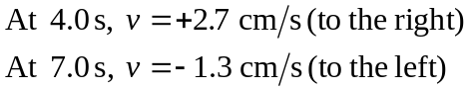
b) which is constant
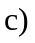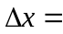area under v-t graph
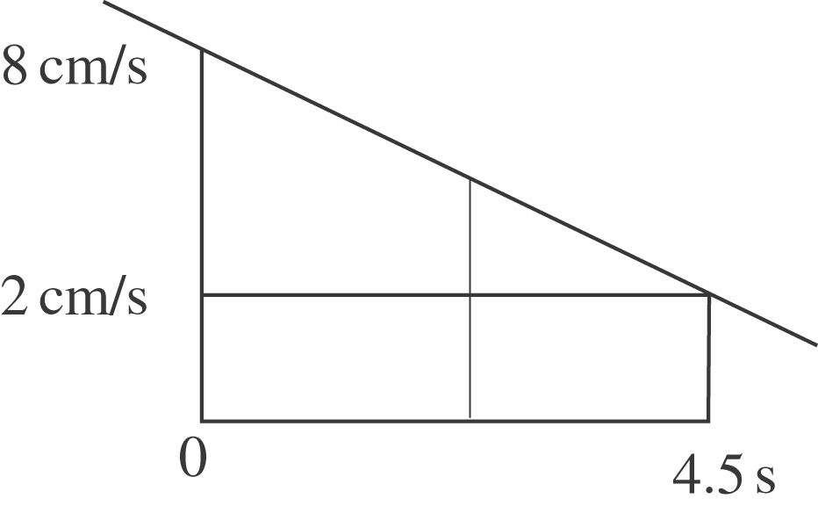

First 4.5 s:
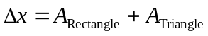
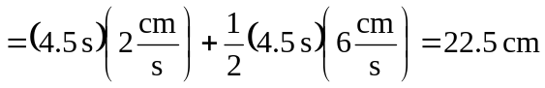

From 0 to 7.5 s:
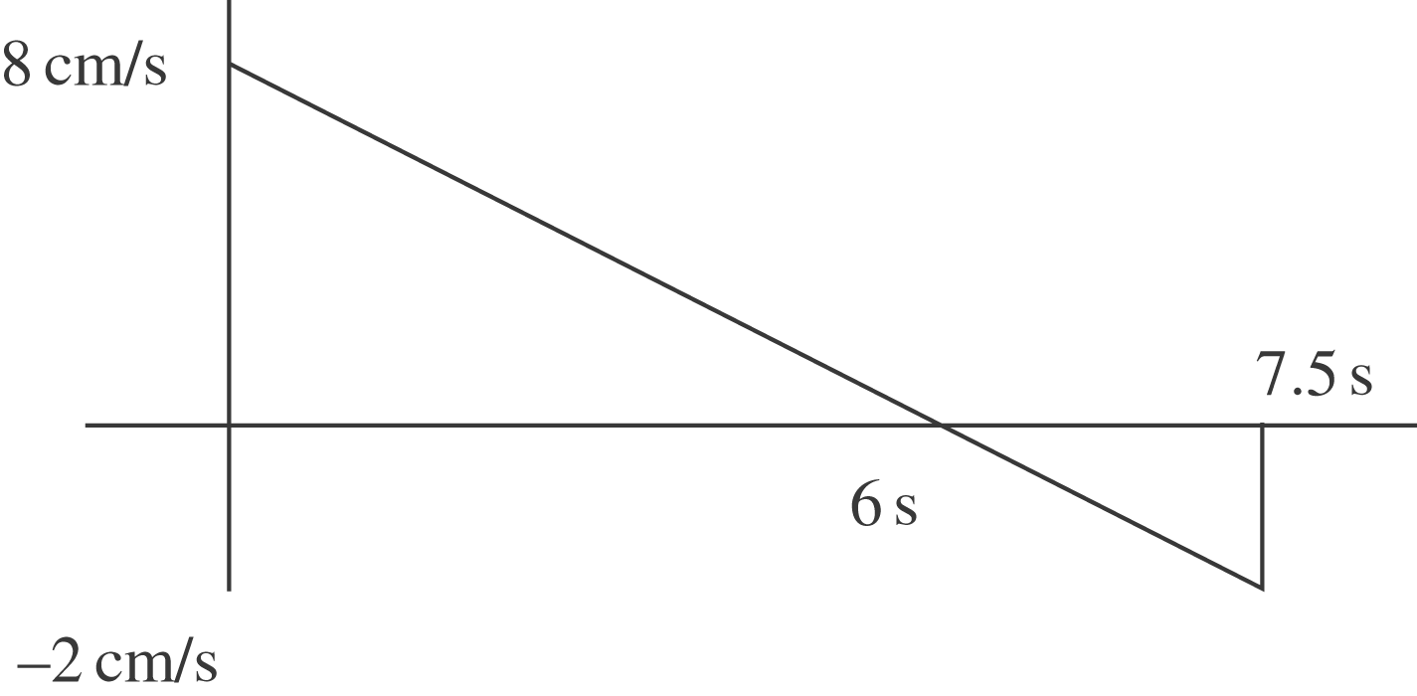

The distance is the sum of the magnitudes of the areas.
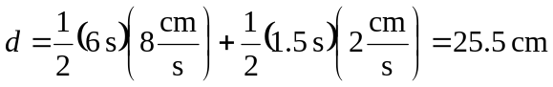

d)
